Tina Sherwell

596 words

**Tamari, Vera (1945--)**

Vera Tamari was born in 1945 in Jerusalem, to parents from the coastal city of Jaffa. Her parents were lovers of art, and exposed their children to art, music and literature from an early age. Vera’s older brother Vladmir Tamari is also an artist based in Japan, while her sister Tayna is a classical singer. Tamari received her BA in Fine Arts at the Beirut Women’s’ College between 1962-1966, then pursued her studies in Florence in ceramics between 1972-1974, and in 1982 received an M.Phil In Islamic Art and Architecture from Oxford University. She established the first ceramic art studio, in Ramallah and held the post of Professor in Islamic Art and Architecture at Birzeit University in the West Bank until her recent retirement. She is active as a curator, artist and writer. At the university she played a particular active role in bringing art and culture to the life of the students and the campus. Several major themes remain consistent in Tamari’s work throughout her career. In her early work Tamari drew inspiration from traditional ceramics, which she integrated along with specific references alluding to the long history of the tradition of Palestinian ceramics. In the late 1970s and early 1980s her work negotiated specifically her relationship to the Palestinian landscape, through 3-dimensional and relief works that mapped out its terrains.

Tamari has also been concerned with the representations of women. In her early work of the 1970s, she engaged with women’s traditional roles as harvesters, craft-makers, olive pickers, toilers of the earth, and later their struggle and the silent strength of women in their role in the first Intifada (uprising). After the second intifada of 2000 Tamari revisited this theme with a new body of work in mixed media of drawing and prints which focused in particular on the lament of women and their experience of loss as mothers of martyrs. In response to the Israeli Army incursions into Ramallah in 2002, she created a monumental installation from the cars crushed by Israeli tanks, titled *Going for a Ride?*

Her relationship to the past, particularly memories of Jaffa, were explored in the late 1990s series of works in which the artist revisited old family photographs and recreated in relief work, the gestures, human relations and nuances of places. The work included intimate details of verandas, house-fronts and courtyards. This engagement with the past, and expression of loss, longing and nostalgia comes to the foreground in the work *Oracles of the Sea* (1998); a mixed media installation which consisted of ceramic faces lined and cracked by time with hollowed eyes. The work was installed on the seashore of Jaffa, and explored the issues of identity and history in an imaginary return of her ancestors to Jaffa, where, the sea occupies the space of the eyes in a haunting image of loss and longing.

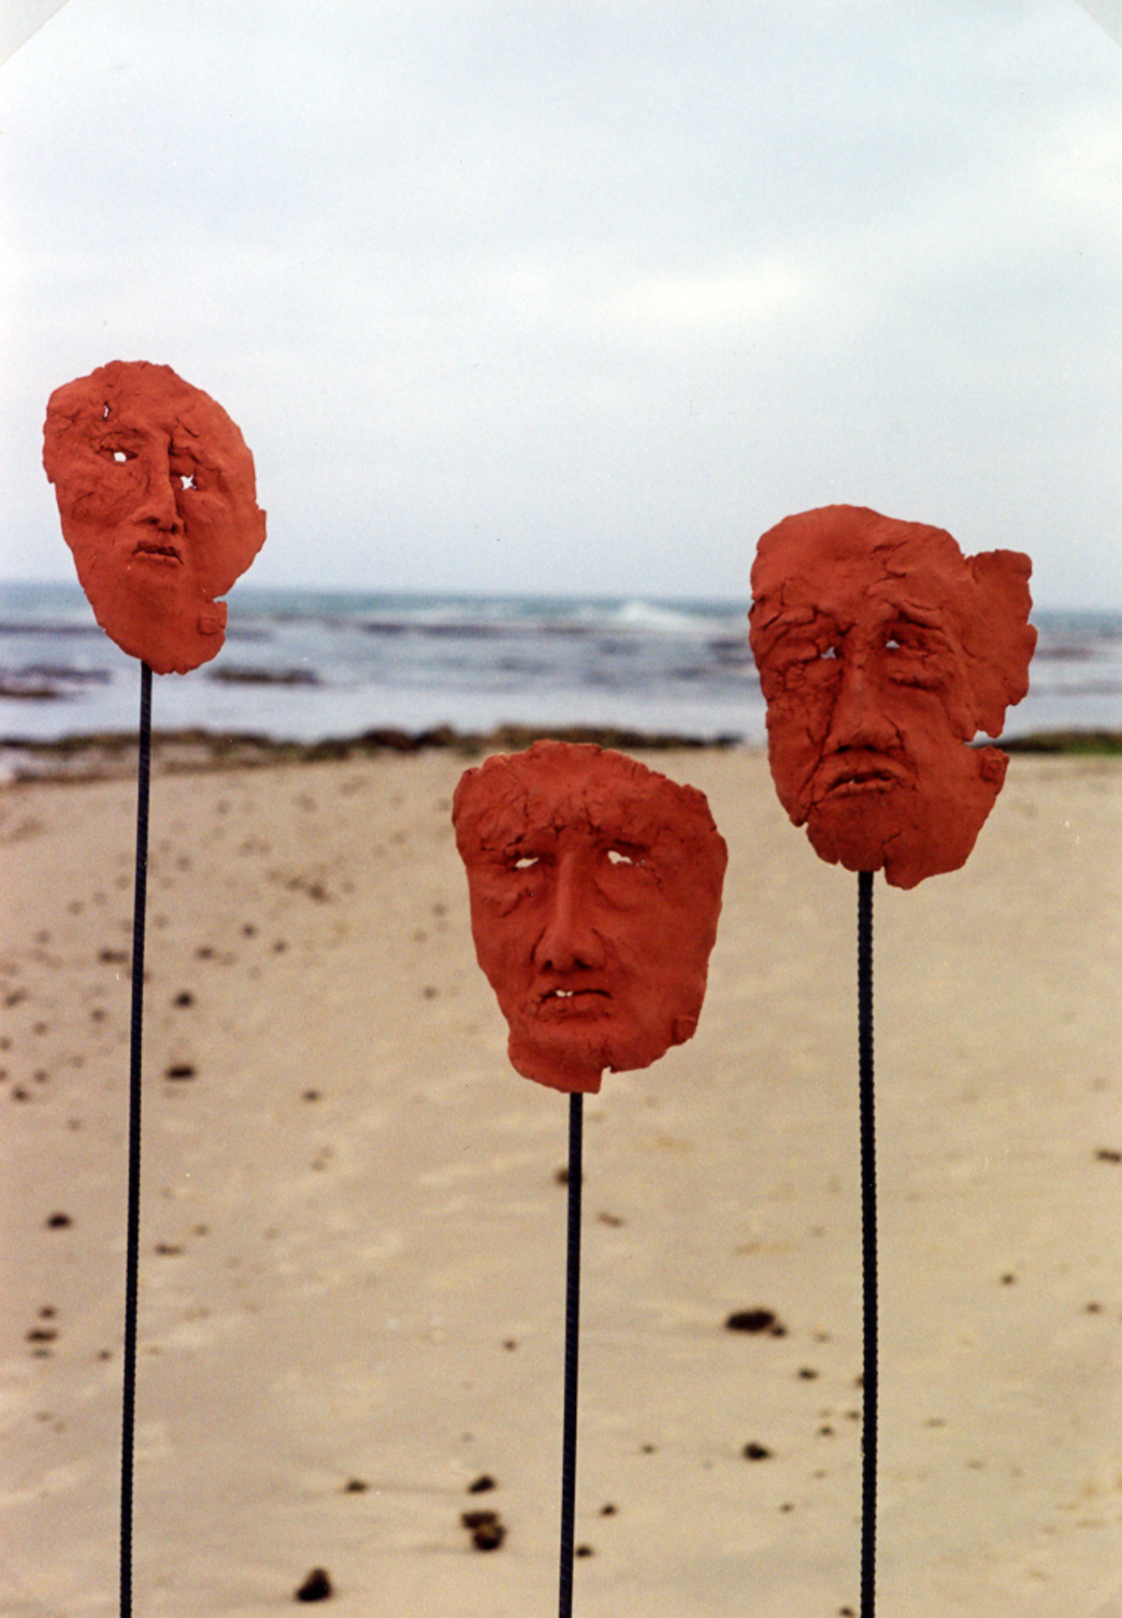

**Vera Tamari, Oracles from the Sea, 1998**

For permission contact: [vera@palnet.com](mailto:vera@palnet.com) or [vtamari@birzeit.edu](mailto:vtamari@birzeit.edu)

**References and further Reading**

Boullata, Kamal (2009) *Palestinian Art****:*** *From 1850 to the Present,* Saqi Books, London.

Johnson, Penny (2007) “ Ramallah Dada: The Reality of the Absurd” *Jerusalem Quarterly*, Nov. 16.

Malt, Carol (Spring 2001) "Vera Tamari: A Palestinian Woman of Tradition," *Ceramics Monthly.*

Tamari, Vera and Penny Johnson (1995) “Loss and Vision: Representation of Women in Palestinian Art Under Occupation” in *Discourse and Palestinian Power Text and Context,* Annelis Moors et al, eds.

Tamari, Vera and Suad al Amiry (1989) *The Palestinian Village Home*, the British Museum Press.

Tatchdjian, Selva (1995) “Vera Tamari,“Memoire Palestinienne,*” Revue de la Ceramique et du Verre*.

Zarur, Kathy (September 2006) “Looking at the Levant*” Art in America.*

Video Interview- Featured Artist of the Month <http://virtualgallery.birzeit.edu/media/video?item=68138>